Gator Junior Golf Association
Intermediate Rules Quiz
Week 3
INTERMEDIATE: RULES QUIZ WEEK 3
Label the parts of the golf course using the word bank:
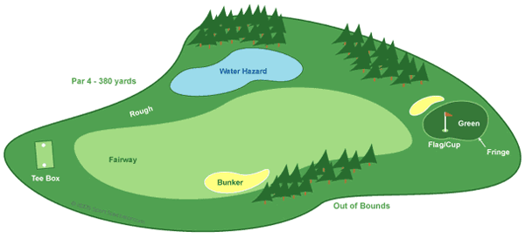
Word Bank
Bunker Fairway Water Hazard
Green Rough
Fringe Tee box

Answer the following questions:
1. What is the maximum number of clubs you can have in your golf bag? What is the penalty for breaking this rule (per hole)?
  - 12; 2 strokes
  - 14; 2 strokes
  - 16; 1 stroke
  - unlimited; no penalty
- True or False: You cannot ask for advice from anyone except your caddie or partner.
- Which of the following is NOT allowed?
  - Taking a practice STROKE during a hole
  - Taking a practice SWING during a hole
  - Practicing chipping on the tee box
  - Practicing putting on a green already played
- True or False: Slow play can be penalized.
- The first thing you should do when starting your round is ___________ ____________ __________ because if you cannot, your ball is considered lost .
- What should you shout if you think your ball will hit someone? ____________

