Gator Junior Golf Association
Intermediate 1 Rules Quiz
Week 3
Max Meier
INTERMEDIATE 1: RULES QUIZ WEEK 3
Label the parts of the golf course using the word bank:
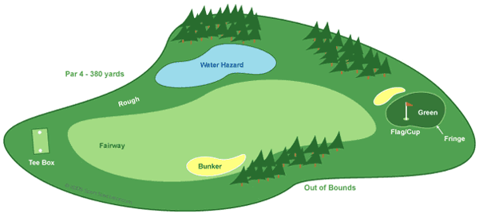
Word Bank
Bunker Fairway Water Hazard
Green Rough
Fringe Tee box

Answer the following questions (hint: go to https://gatorjuniorgolf.org/intermediate-1-course-notes):
- What is the maximum number of clubs you can have in your golf bag? What is the penalty for breaking this rule?
  - 12; 2 strokes
  - 14; 2 strokes
  - 16; 1 stroke
  - unlimited; no penalty
- True or False: You cannot ask for advice from anyone except your caddie or partner.
- Which of the following is penalized 2 strokes?
  - Taking a practice STROKE during a hole
  - Taking a practice SWING during a hole
  - Practicing chipping on the tee box
  - Practicing putting on a green already played
- True or False: Slow play can be penalized.
- The first thing you should do when starting your round is ___________ ____________ __________ because if you cannot, your ball is considered lost .

