Gator Junior Golf Association Name:______________
Intermediate Rules Quiz
Week 3 – Chapter 3 (Parts of the Golf Course)

INTERMEDIATE: RULES QUIZ WEEK 3
Teeing Ground, Parts of the Golf Course, Honors
Answer the following questions. Assume the situations take place in stroke play:
- Use the diagram below to answer this question: Which player described will NOT be penalized?
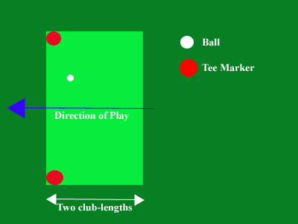

- Jim tees his ball three club-lengths behind the tee markers
- Jimmy tees his ball one club-length behind the tee markers
- James tees his ball one club-length in front of the tee markers
- Jimothy tees his ball directly outside of the tee markers, but his feet remain within the tee markers
- Circle all of the situations in which the player’s stroke will count.
  - Jim tees up his ball and addresses it, but accidentally knocks it off the tee
  - Jimmy intends to hit his ball after teeing it up, swings, and misses it
  - James takes a practice swing and accidentally hits his ball
  - Jimothy addresses his ball and swings right under the tee, missing the ball completely
- What is the FIRST thing you should do in a round?
  - Tee up your ball
  - Address your ball
  - Identify your ball
  - Count your clubs
- James, Jim, Jimmy, and Jimothy are playing golf at Gainesville Country Club. Jim goes first, and gets a 5 on the first hole, a par 5. James is next, and he also gets a 5. Jimmy gets a 4. Jimothy gets an 8. Who should go SECOND on the next hole?
  - James
  - Jim
  - Jimmy
  - Jimothy
- Label the parts of the golf course using the word bank below:
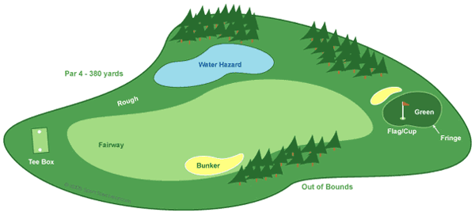

Word Bank
Bunker Fairway Water
Green Rough
Fringe Tee box

